Exp 4: The string is a sequence of characters placed in double quotes (” “).Performing different operations on string data is called StringHandling. Strings are immutable. Whenever a change to a String is made,an entirely new String is created. If we want to store a group ofcharacters we can use a char array. String provides various methods toperform different operations on strings. Using Raptor draw a flowchartto display the total number of characters in the string and returns it.

Step 1: Open RAPTOR
- Open RAPTOR software.
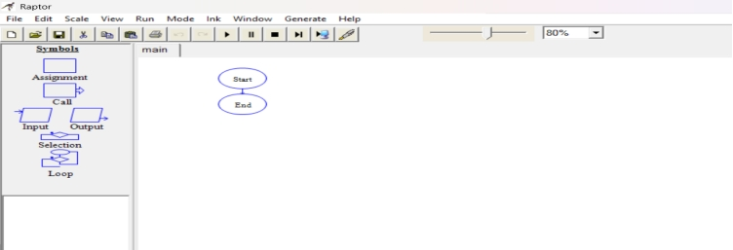

Step 2: Insert Input Symbol
- Click Input from the left toolbar.
- Click on the flowline between Start and End.
- Enter: str , Click OK.
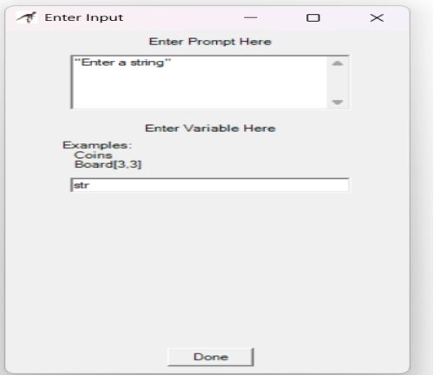
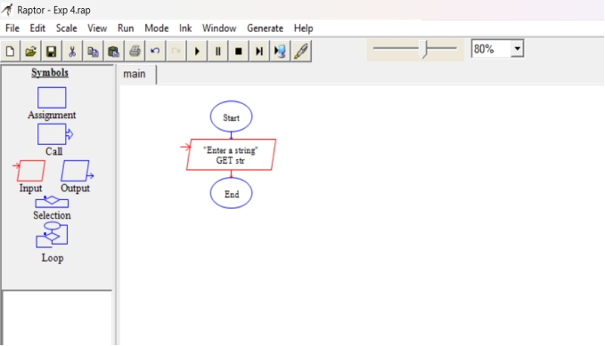

Step 3: Insert Assignment Symbol
- Click Assignment from the toolbar.
- Place it below Input str.
- Enter:
count <- Length_Of(str)
- Click OK.
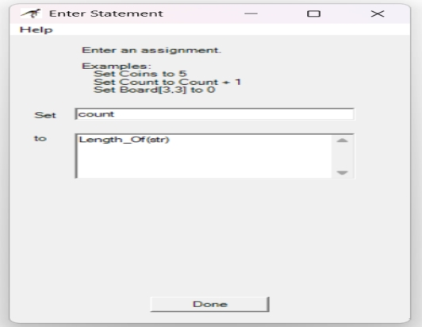
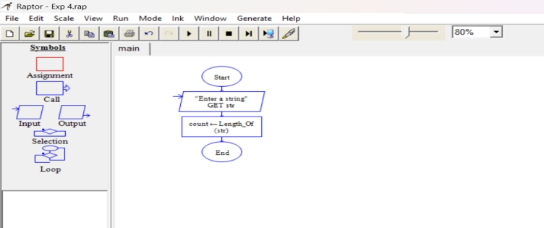

Step 4: Insert Output Symbol
- Click Output from the toolbar.
- Place it below the Assignment symbol.
- Enter:
"Total Characters = ", count
- Click OK.
Step 5: Run the Flowchart
- Click Execute → Run or press F5.
- A dialog box appears.
- Enter a string.
Example:
HELLO
- Click OK.
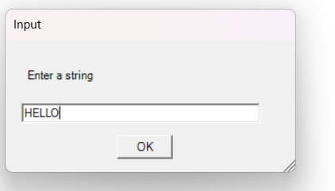

Step 6: View Output
Output:
Total Characters = 5
